**CS110 Computer Science Fundamentals Midterm 1 2nd March 2023**

*Name: _________________________________*

*Please observe the Emory College Honor Code while taking this test. NOTE: You* ***must*** *show all work; the final answer alone will give you little credit, if any.*

1. (4 points) Choose one correct answer: the smallest basic unit of data representation and computing is:

(a) byte

(b) word

(c) bit

(d) cpu

(e) boolean

2. (8 points) What is the value of the output (Y) of the circuit shown below when

**(a)** A=1, B=1; C=1 and **(b)** A=0; B=0; C=0

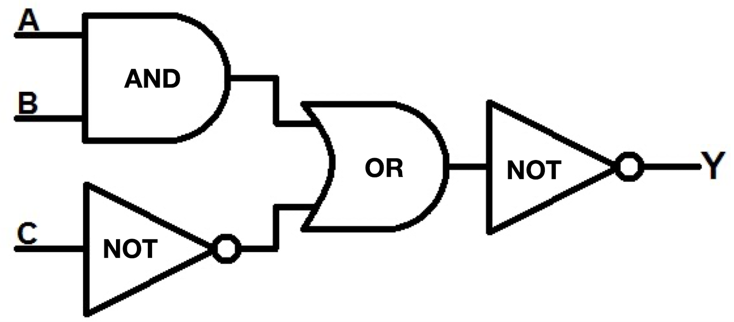

3. (6 points) What is the decimal value of the 8 bit positive integer 01110111

4. (6 points) What is the binary representation, using 8 bits, of the decimal integer 34

5. (12 points) What are the values of the variables on the left hand side after these Python statements are executed?

1. eye = 37 + 9 // 5 * 32
2. eyeeye = 37 + 9 % 5 * 32
3. pi = 17 % 5 + 1.14
4. pad = ‘s’ + ‘b’ + ‘23’

6. (8 points) Replace the stars below so that this Python segment prints “Yes” if the input begins and ends with the same character, and “No” otherwise. You should replace *** in each place shown with your own code

ss = input(“Please enter a word or a any sequence of characters”)

el = len(s)

bee = 0

zee = ***

if ss[bee] == *** :

print (“***”)

else:

print (“***”)

print (“That’s all folks”)

7. (10 points) What does this Python code segment print?

k = 1

s = 0

while k <= 100:

if k % 23 == 0 :

s = s + 1

elif k % 33 == 0:

s = s – 1

k = k + 1

print (s)

8. (12 points) Modify the program below (fill in statements where indicated) so that it prints “Yum” after every 3 "Chomp"s. So the program should print: "Chomp Chomp Chomp Yum Chomp Chomp Chomp Yum . . ."

A total of 10 "Chomp"s and 3 "Yum"s should be printed.

k = 0

while k < 10:

k = k + 1

print (“Chomp”)

*** FILL IN STATEMENTS HERE ***

print(“Done, close the fridge”)

9. (14 points) Give example inputs for the program below: **(a)** Give one example input that causes the program to print “Yes” and **(b)** give another example input that causes it to print “No”

def rev (s1):

n = len(s1) -1

s2 = ‘’

while (n >= 0):

s2 = s2 + s1[n]

n = n -1

return (s2)

x = input (“Please enter a word”)

y = rev(x)

if (x == y):

print(“Yes”)

else:

print (“No”)

10. (20 points) Define a function to accept an integer and return its factorial (For example, 4 factorial is 4*3*2*1). Write a program to ask the user to input a number, invoke your factorial function, and print the value it returns